PROJECT OVERVIEW
Introduction
Retail businesses depend heavily on accurate, accessible customer data to support sales, service, and relationship management. As part of a broader modernization initiative, the engineering team has been tasked with building a Customer Management System — a lightweight application that allows staff to add, view, update, and delete customer records — and, more importantly, to deliver it using modern software engineering practices rather than manual, ad-hoc processes.
This project is not just about writing code. It is designed to demonstrate an end-to-end software delivery workflow using Azure DevOps, covering four connected disciplines: Agile planning, source code management, continuous integration, and validation. Together, these represent the core practices that modern engineering teams use to plan, build, and reliably deliver software.
Business Context
The Product Owner has defined a single business requirement (the Epic) that captures the retail company's need:
Develop a Customer Management System for a Retail Company — the application should allow users to manage customer records by adding, viewing, updating, and deleting customer information.
Rather than handing this requirement directly to a developer to build in isolation, the team follows an Agile, DevOps-driven approach: the requirement is broken down into a structured backlog, the resulting code is stored in a version-controlled repository, and every change is automatically built and validated through a Continuous Integration pipeline. This ensures the system is not only functional, but also maintainable, traceable, and safe to change over time.

PART 1 – AGILE PLANNING: DETAILED REPORT
Part 1 – Agile Planning
Objective
Break down the business Epic into Features, User Stories, and Tasks, and create the complete work hierarchy inside Azure DevOps Boards, so that the work is organized, estimable, trackable, and traceable back to the original business requirement.
Understanding the Work Item Hierarchy
Before building the hierarchy, it's worth understanding what each level represents and why this structure matters:
- Epic — the largest unit of work, representing a full business initiative that is too large to complete or estimate directly. It is broken down into smaller pieces because no single team member could reasonably size or deliver it as one unit.
- Feature — a distinct, functional capability that supports the Epic. Features group related pieces of work under one functional theme, answering the question: "What major capability does this add to the product?"
- User Story — a specific requirement described from the end user's perspective, typically in the form "As a [role], I want [goal], so that [benefit]." User Stories are small enough to realistically complete within a single sprint.
- Task — the smallest, most concrete unit of work: a specific technical action a developer performs to help deliver a User Story. Tasks are the unit used for day-to-day tracking.
This layered structure gives visibility at every level of the organization — business stakeholders can track progress at the Epic and Feature level, Product Owners manage priority at the User Story level, and developers track daily progress at the Task level — all automatically rolled up together.
Process Template Consideration
While setting up the work items, it was discovered that the assigned Azure DevOps project (Project-B02, under the Hexaware-DevopsBatch2 organization) had been provisioned using the Basic process template, rather than the Agile process template. This is an important distinction:
Process Template | Work Item Hierarchy
Basic (what this project uses) | Epic → Issue → Task
Agile | Epic → Feature → User Story → Task
Scrum | Epic → Feature → Product Backlog Item → Task

The Basic template only provides three levels, with a single generic Issue type sitting between Epic and Task — there is no dedicated Feature or User Story work item type available. To preserve the intended four-level breakdown required by the assignment (Features and User Stories as distinct concepts) within these constraints, each Issue was used to represent a User Story, and was explicitly prefixed with its corresponding Feature name in square brackets — for example, [Customer Record Management] Add Customer. This naming convention preserves full logical traceability from Feature grouping → User Story → Task, even though "Feature" is not a literal work item type available in this instance of Azure DevOps.
Complete Work Hierarchy Created
Epic 132 — Develop a Customer Management System for a Retail Company
Description: The application should allow users to manage customer records by adding, viewing, updating, and deleting customer information.
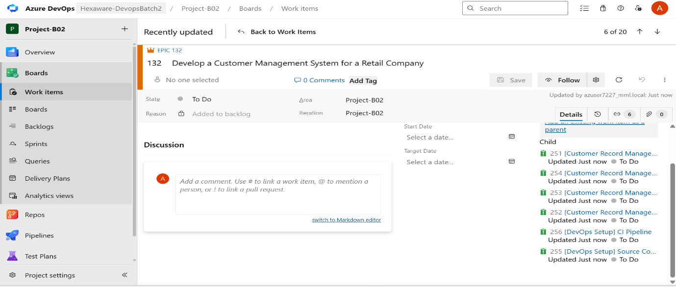
Feature: Customer Record Management
Purpose: Deliver the core CRUD functionality — the primary business value of the application.
Issue 251 — [Customer Record Management] Add Customer
- Task 257: Design Customer data model (customer_id, name, email, phone)
- Task 258: Implement add_customer() method
- Task: Add duplicate-ID validation
- Task: Write unit test for add_customer()
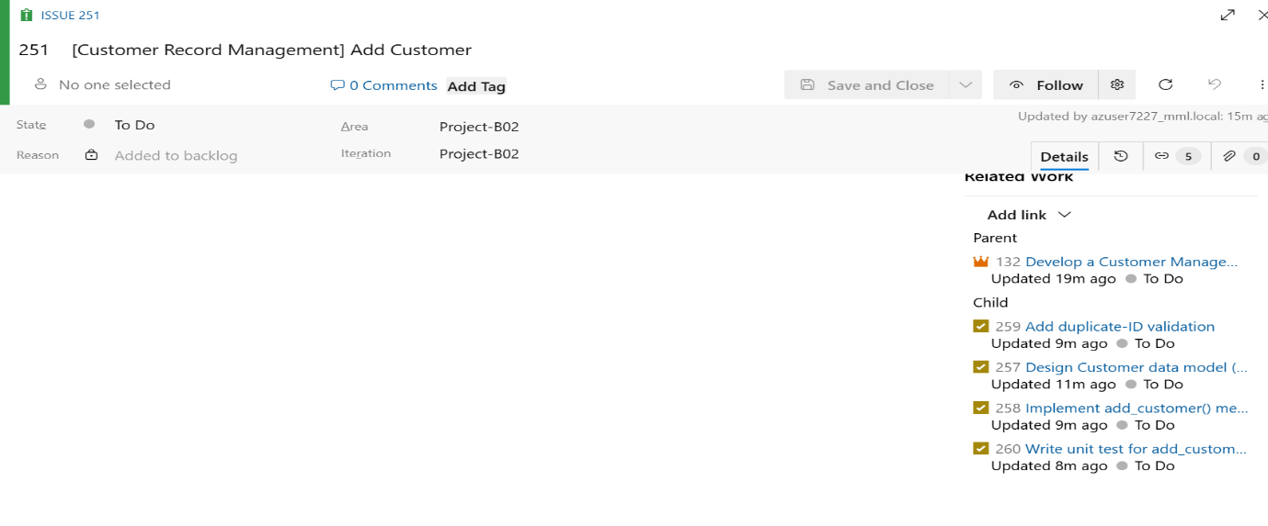
Issue 252 — [Customer Record Management] View Customer
- Task: Implement view_customer() for a single record
- Task: Implement view_all_customers() for listing all records
- Task: Format console output for readability
- Task: Write unit test for view methods
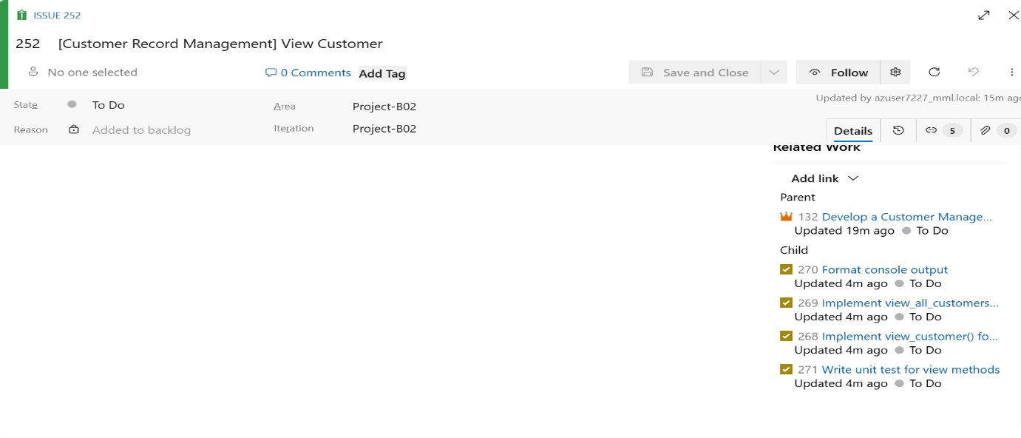
Issue 253 — [Customer Record Management] Update Customer
- Task: Implement update_customer() method
- Task: Handle case where customer ID does not exist
- Task: Support partial updates (e.g., only phone number)
- Task: Write unit test for update_customer()
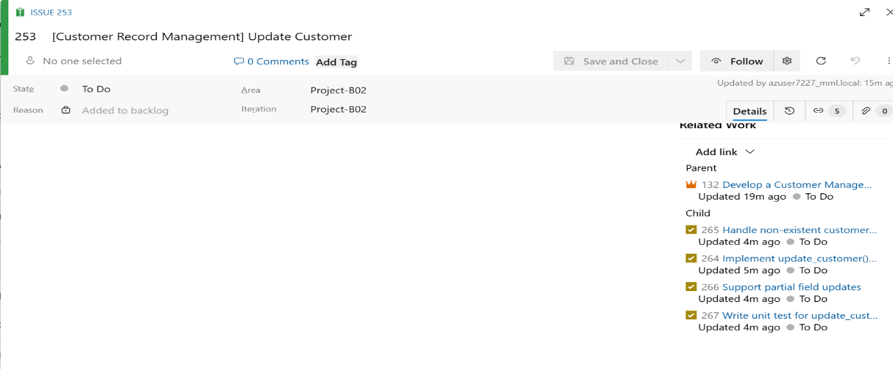
Issue 254 — [Customer Record Management] Delete Customer
- Task: Implement delete_customer() method
- Task: Handle case where customer ID does not exist
- Task: Write unit test for delete_customer()
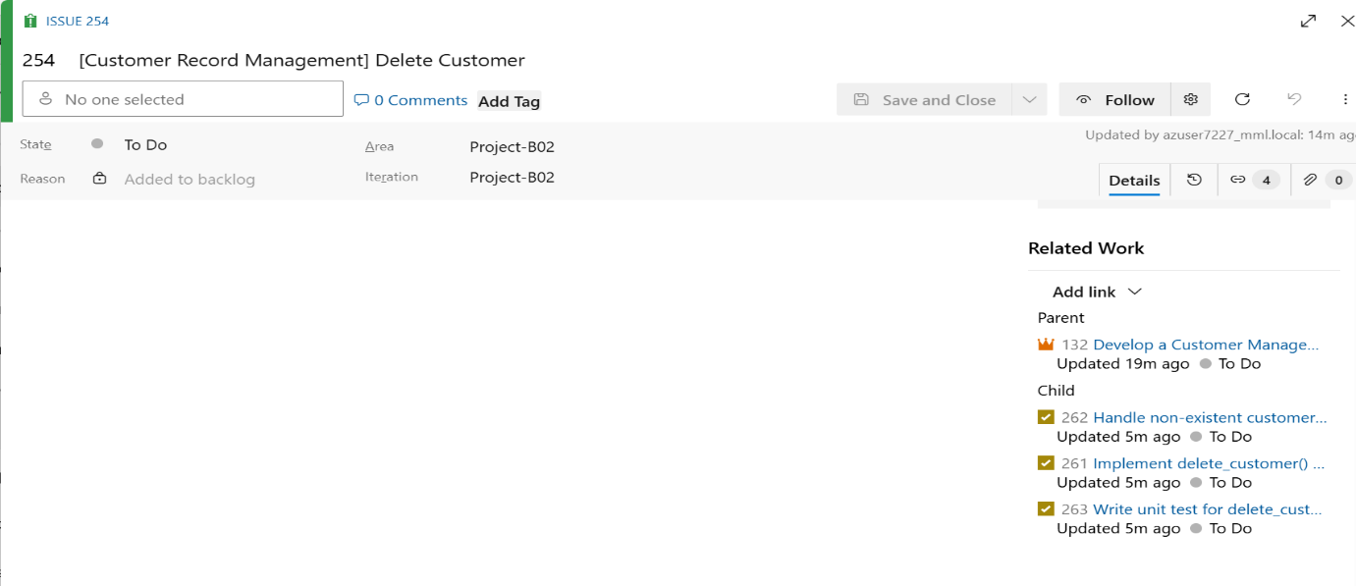
Feature: Application Infrastructure & DevOps Setup
Purpose: Ensure the application is version-controlled and automatically validated on every change.
Issue 255 — [DevOps Setup] Source Control Setup
- Task: Create the repository customer-management-system
- Task: Add .gitignore and README
- Task: Commit and push initial application code
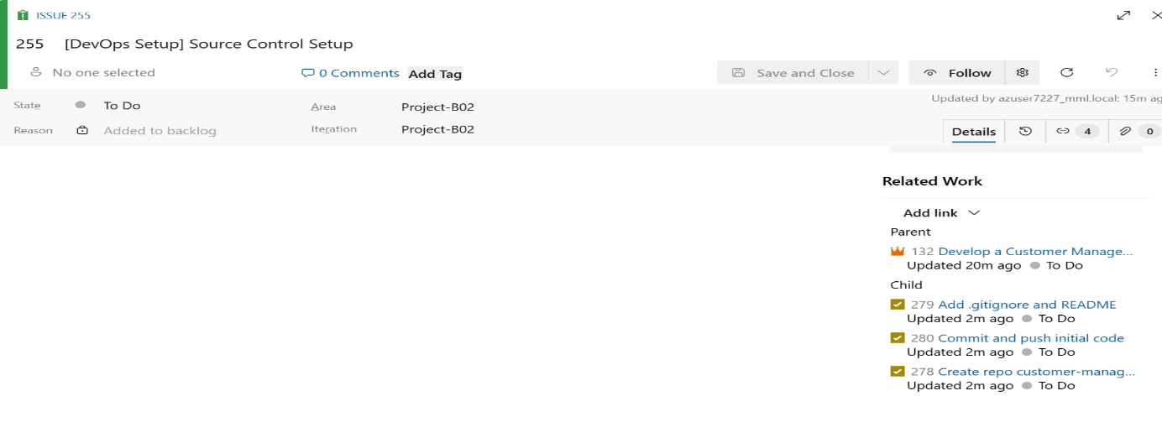
Issue 256 — [DevOps Setup] CI Pipeline
- Task: Create azure-pipelines.yml
- Task: Configure trigger on main branch commits
- Task: Add step to set up Python environment
- Task: Add step to install project dependencies
- Task: Add step to execute the application
- Task: Validate that output appears in pipeline logs
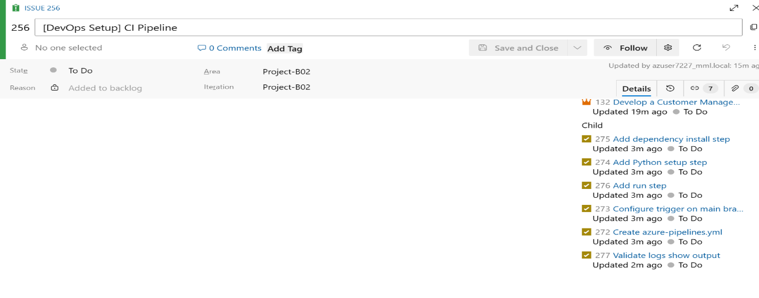
Summary Table with output:
Level | Item | Count
Epic | Customer Management System | 1
Feature (grouping) | Customer Record Management, DevOps Setup | 2
Issue (User Story) | Add, View, Update, Delete, Source Control, CI Pipeline | 6
Task | Individual implementation/test/setup tasks | 21

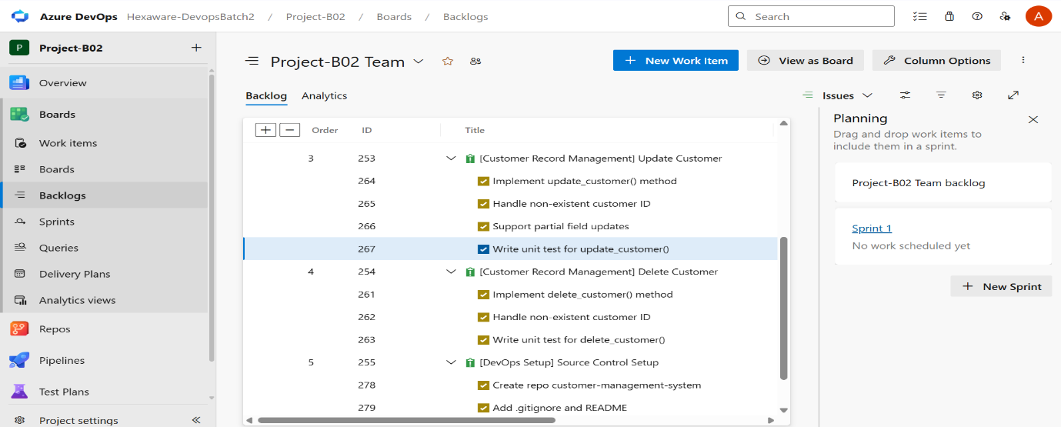

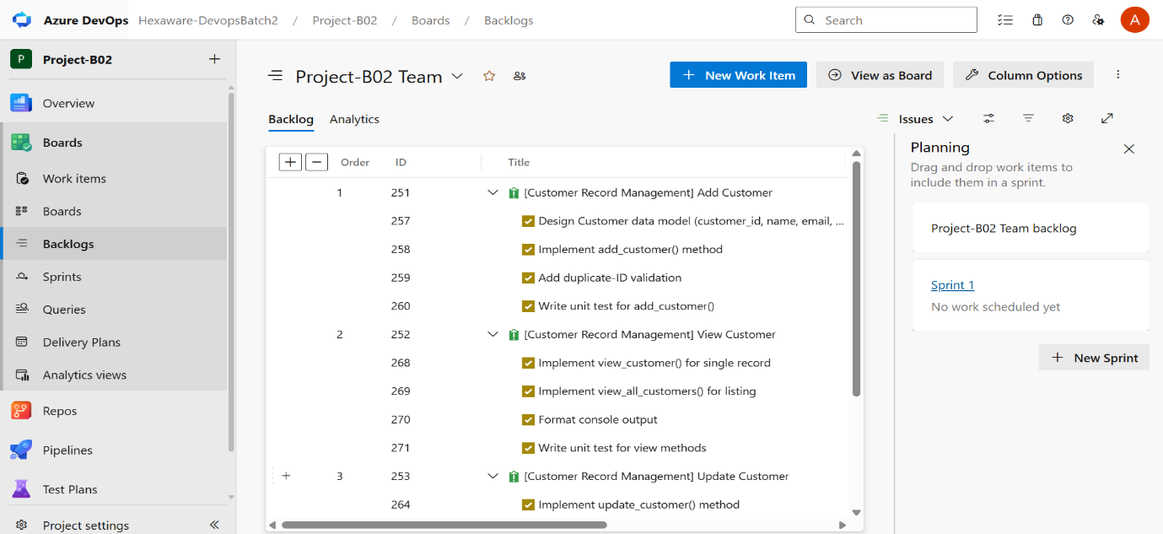

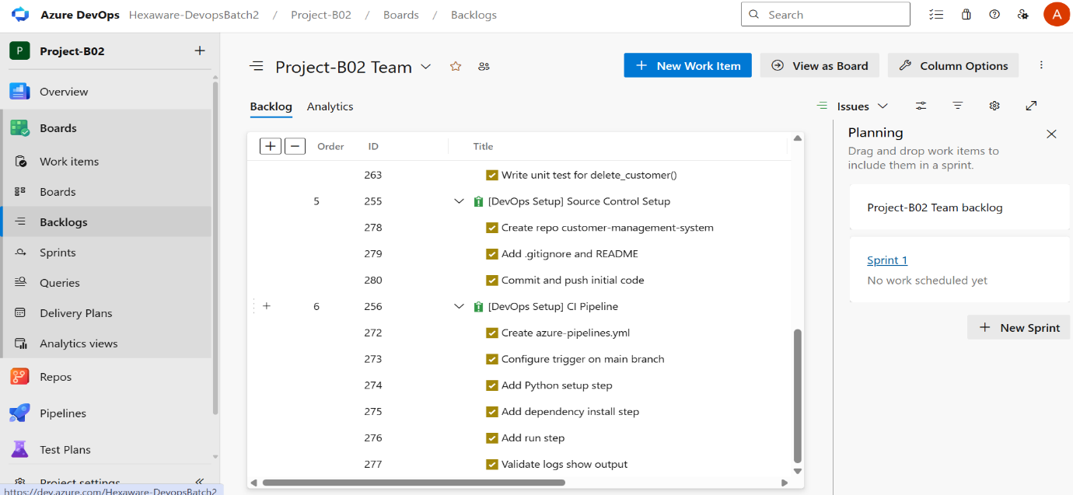

PART 2 – SOURCE CODE MANAGEMENT: DETAILED REPORT
Objective
Translate the planned User Stories and Tasks from Part 1 into actual working code, stored in a version-controlled Git repository within Azure DevOps. This ensures the application is traceable back to the Agile backlog, auditable through commit history, and forms a stable foundation for the Continuous Integration pipeline in Part 3.
Scope of This Part
- Set up source control for the Customer Management System application.
- Develop a Python application implementing full CRUD (Create, Read, Update, Delete) operations for customer records.
- Commit and push the source code to the Azure DevOps Git repository.
- Establish supporting files (README.md, .gitignore) for a clean, professional repository structure.
Repository Setup
- The application code was version-controlled using the existing Git repository provisioned under the Hexaware-DevopsBatch2 organization, Project-B02.
- As repository creation permissions were restricted at the individual contributor level, a new standalone repository named customer-management-system could not be independently created.
- The shared project repository was used instead to host the source code, consistent with how the rest of the team's repositories are managed under this organization.
- The main branch was used directly for development and commits, in line with the scale of this project.
Application Development
The Python application was developed to satisfy the Customer Record Management feature defined in Part 1, implementing full CRUD functionality through two classes:
- Customer — represents a single customer record.
  - Attributes: customer_id, name, email, phone
  - Method: display() — prints record details in a readable format
  - (Satisfies Task 257 — Design Customer data model)
- CustomerManager — handles all business logic for managing customer records:
  - add_customer() — adds a new customer, with duplicate customer_id validation (Issue 251)
  - view_customer() — retrieves and displays a single customer record by ID (Issue 252)
  - view_all_customers() — lists all stored customer records (Issue 252)
  - update_customer() — supports partial updates (e.g., updating only the phone number) and handles non-existent customer IDs (Issue 253)
  - delete_customer() — removes a customer record, with handling for non-existent IDs (Issue 254)
- A main() function demonstrates the full workflow end-to-end:
  - Adding multiple customers
  - Attempting to add a duplicate ID (validation check)
  - Viewing all records and a single record
  - Updating a customer's phone number
  - Deleting a customer, including an attempt to delete a non-existent ID
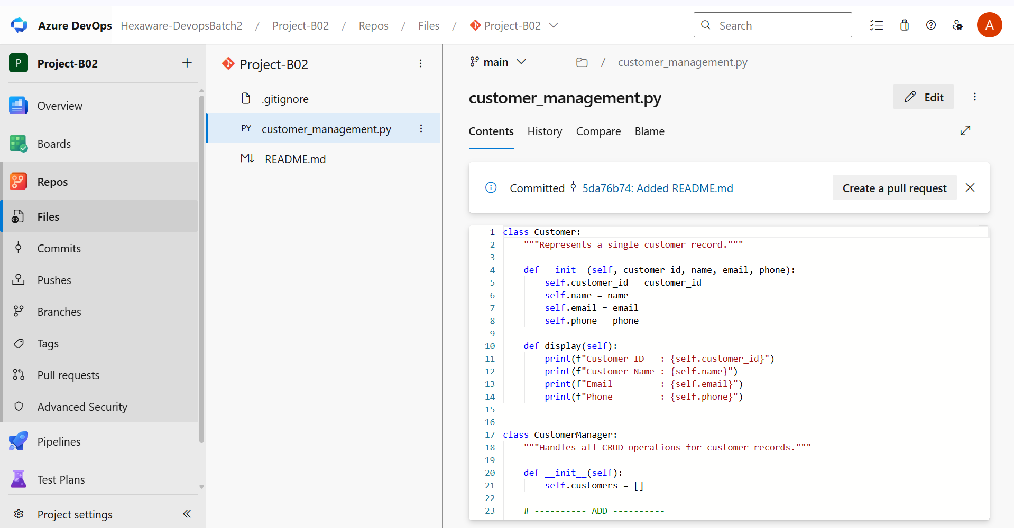Design Decisions
- Object-oriented design was chosen to separate data representation (Customer) from business logic (CustomerManager), improving readability and making the code easier to extend or unit test later.
- In-memory storage (a Python list) was used to keep the application lightweight and dependency-free, matching the "simple Python application" requirement.
- Defensive checks (duplicate ID on add, missing ID on update/delete) were added directly, even though the base example provided did not include them, to align with the validation-related tasks under Issues 251, 253, and 254.
Supporting Files
- README.md — added to describe the purpose of the application and how to run it, satisfying part of Issue 255 (Source Control Setup).
- .gitignore — added to exclude Python bytecode and virtual environment folders (__pycache__/, *.pyc, .venv/) from version control, keeping the repository clean.
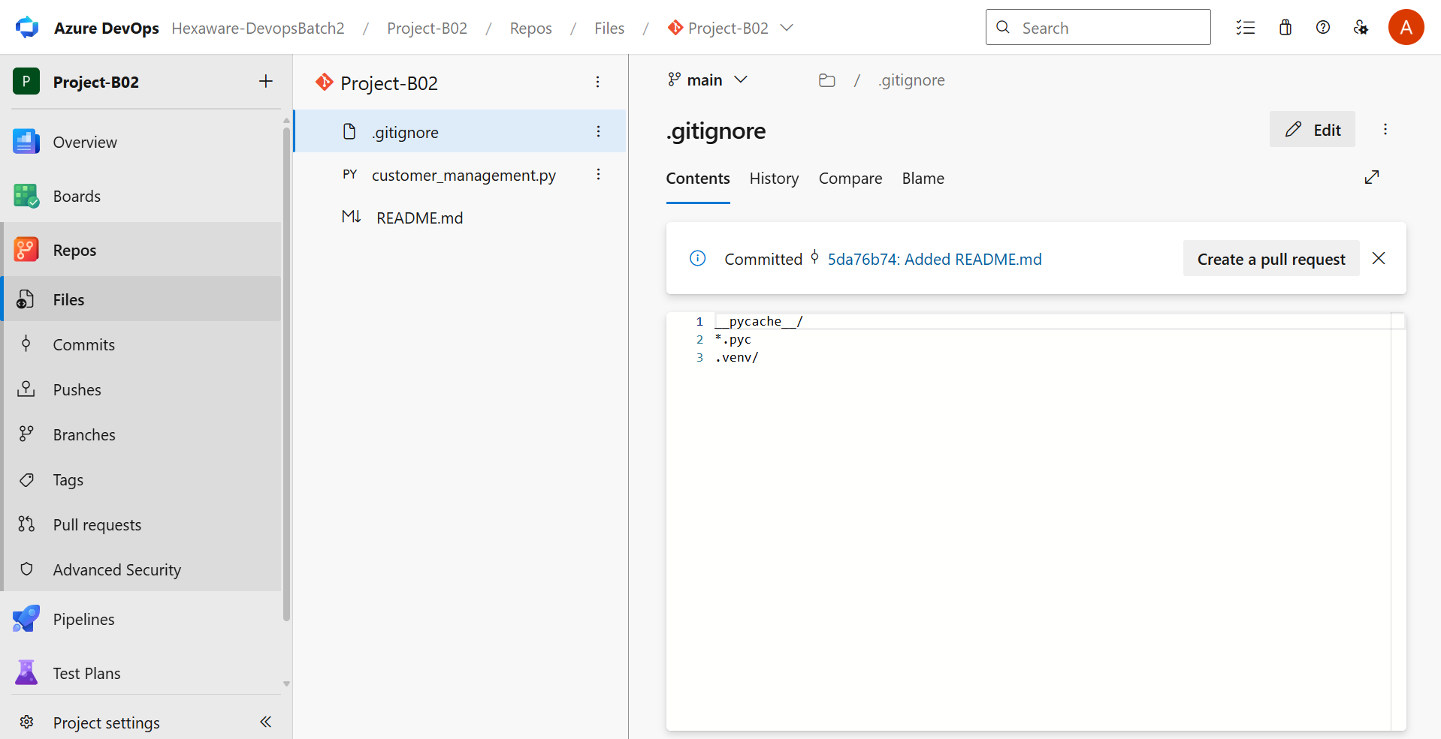

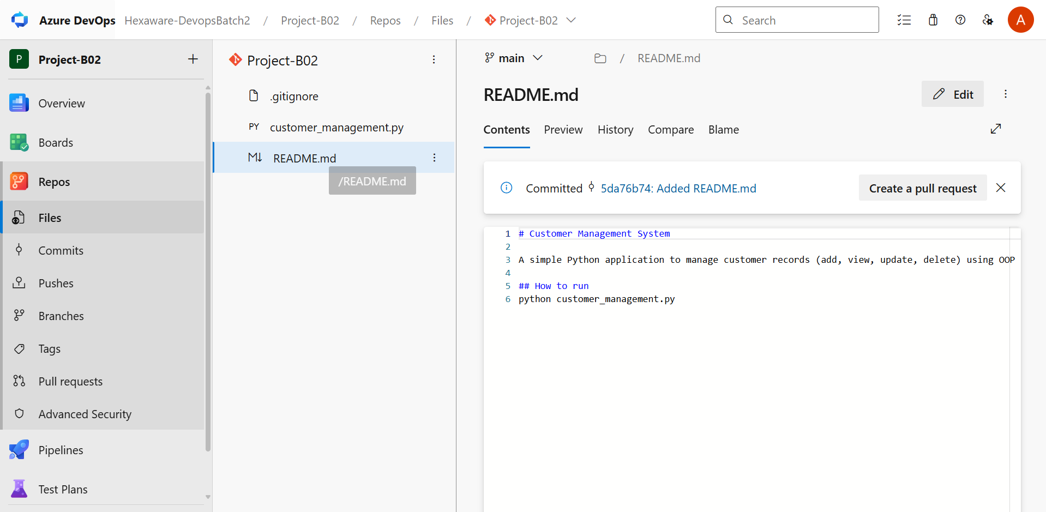
Commit and Push
- The completed source code was committed directly to the main branch through the Azure DevOps web interface, which commits and pushes the change to the remote repository in a single action — no separate local git push step was required.
- The commit was recorded under commit ID 948b8f6b with the message "Added customer_management.py".
- Subsequent commits added the supporting README.md and .gitignore files.
Traceability to Part 1
Work Item | Description | Status
Issue 251 | Add Customer | Implemented via add_customer()
Issue 252 | View Customer | Implemented via view_customer(), view_all_customers()
Issue 253 | Update Customer | Implemented via update_customer()
Issue 254 | Delete Customer | Implemented via delete_customer()
Issue 255 | Source Control Setup | Repository used, code committed and pushed, README/.gitignore added

PART 3 – CONTINUOUS INTEGRATION (CI): DETAILED REPORT
Objective
Set up a Continuous Integration pipeline in Azure DevOps that automatically retrieves the source code, configures the required environment, installs dependencies, and executes the application on every commit to the main branch — ensuring the codebase is validated automatically rather than relying on manual checks.
Scope of This Part
- Create an azure-pipelines.yml file defining the CI workflow.
- Configure the pipeline to trigger automatically on commits to main.
- Set up a Python environment within the pipeline agent.
- Install project dependencies conditionally, since the application has no external dependencies.
- Execute the Python application and verify its output appears in the build logs.
- Confirm the pipeline completes with a successful (green) status.
Pipeline Configuration (azure-pipelines.yml)
The pipeline was defined as a single-stage YAML pipeline consisting of four sequential steps:
- Checkout source code — retrieves the latest code from the repository using checkout: self.
- Set up Python environment — uses the built-in UsePythonVersion@0 task to provision Python 3.x on the Ubuntu build agent.
- Install project dependencies — a conditional Bash script checks for the presence of requirements.txt before attempting installation. Since the Customer Management application relies only on Python's standard library, this step simply logs a message and skips installation, rather than failing.
- Run Customer Management application — executes python customer_management.py, which runs the full CRUD demonstration (add, view, update, delete) defined in the application's main() function.

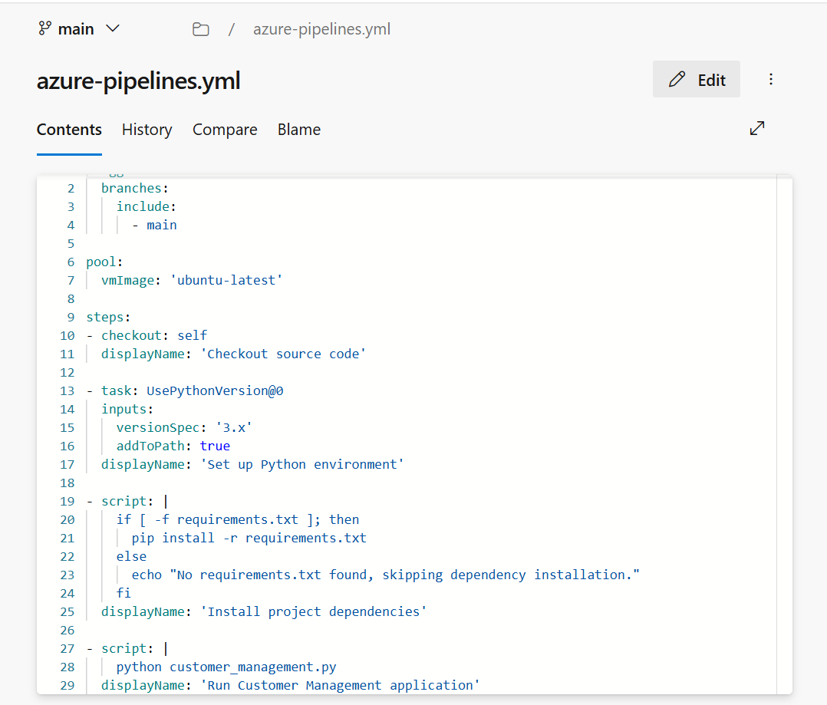

Trigger Configuration
- The pipeline is configured with trigger: branches: include: main, meaning any commit pushed directly to the main branch automatically queues a new pipeline run.
- This removes the need for manual pipeline execution during normal development, satisfying the "Configure trigger on main branch commits" task from Part 1 (Issue 256).
Pipeline Creation in Azure DevOps
- A new pipeline was created under Pipelines → New Pipeline, selecting Azure Repos Git as the source and Project-B02 as the repository.
- The Existing Azure Pipelines YAML file option was used, pointing to /azure-pipelines.yml on the main branch.
- The pipeline was reviewed and run to validate the configuration end-to-end.
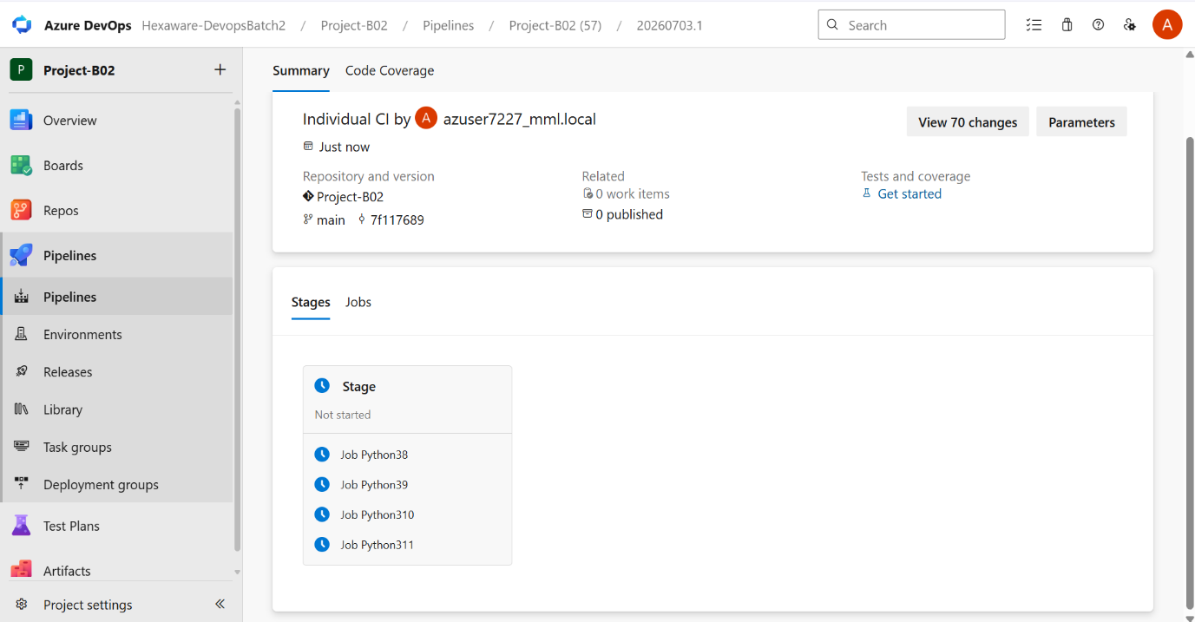Pipeline Execution Results
- Checkout source code — completed successfully, confirming the latest commit from main was retrieved.
- Set up Python environment — completed successfully, provisioning Python 3.x on the ubuntu-latest agent.
- Install project dependencies — completed successfully, logging "No requirements.txt found, skipping dependency installation" since none was required.
- Run Customer Management application — completed successfully, with the application's console output printed directly in the build logs, including:
  - Confirmation messages for customers added
  - Duplicate ID validation output
  - Full customer record listings
  - Update confirmation after a partial update
  - Delete confirmation and non-existent ID handling
Build Status
- The pipeline run completed with a green checkmark, indicating a successful build.
- This confirms the application executes correctly in a clean, automated environment — independent of any local machine setup.

PART 4 – VALIDATION
Objective
Confirm that all components delivered across Parts 1–3 — Agile planning, source code, and the CI pipeline — are correctly in place, functioning, and traceable, providing final assurance that the Customer Management System has been delivered using a complete, working DevOps workflow.
Scope of This Part
- Verify the repository contains the full application source code.
- Verify Azure DevOps Boards contains the complete Agile work item hierarchy.
- Verify the YAML pipeline executes successfully.
- Verify the build completes without errors.
- Verify the application output is visible in the pipeline logs.
Repository Verification
- The Project-B02 repository was reviewed under Repos → Files to confirm the presence of all required source files, including customer_management.py, azure-pipelines.yml, README.md, and .gitignore.
- The Commits history was reviewed to confirm a complete, traceable record of changes, including the initial application commit (948b8f6b) and subsequent commits adding the CI pipeline and supporting files.
- This confirms the repository accurately reflects the current, working version of the application.
Agile Work Item Verification
- Boards → Backlogs was reviewed to confirm Epic 132 (Develop a Customer Management System for a Retail Company) is present and correctly describes the business requirement.
- The Epic was expanded to confirm all six Issues (251–256) are linked beneath it, representing the User Stories for both the Customer Record Management and Application Infrastructure & DevOps Setup features.
- Individual Issues were expanded to confirm their associated Tasks (e.g., Task 257, Task 258, and further validation/testing tasks) are present and correctly nested underneath.
- This confirms full traceability from the Epic down to individual Tasks, consistent with the hierarchy planned in Part 1.
Pipeline Execution Verification
- The latest pipeline run under Pipelines → Pipelines was reviewed and confirmed to have completed with an overall Succeeded status.
- All four pipeline steps — Checkout source code, Set up Python environment, Install project dependencies, and Run Customer Management application — completed successfully with no failures.
- This confirms the YAML pipeline defined in Part 3 executes correctly end-to-end whenever code is pushed to the main branch.
Build Error Verification
- Each pipeline step's logs were individually reviewed to confirm the absence of errors.
- The Install project dependencies step correctly logged "No requirements.txt found, skipping dependency installation", reflecting the application's lack of external dependencies, with no failure raised.
- The overall run summary confirmed a clean Succeeded build status with zero errors or warnings blocking completion.
Application Output Verification
- The Run Customer Management application step logs were reviewed to confirm the application's console output is visible directly within the pipeline.
- The logs display the full output of the main() function, including:
  - Confirmation messages for customers successfully added
  - Duplicate customer ID validation output
  - Complete customer record listings (ID, Name, Email, Phone)
  - Update confirmation after a partial field update
  - Delete confirmation and handling of a non-existent customer ID
- This confirms the application not only builds successfully but also executes correctly and produces the expected, verifiable output within an automated environment.

